Coaching Bundle Organizer: Group Coaching 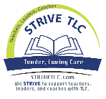

Group Coaching
What did you learn? | What does it mean to you? | What will you do with it? | How will it impact your work?
STRIVE Consulting – SUPPORTING teachers in improving teaching and learning by; building TRUSTING relationships, being RESPONSIVE to teacher needs, using solutions oriented INNOVATIVE thinking, VALIDATING achievement and progress for teachers and students, and ENGAGING with teachers in their hard work. www.strivingreaders.com

